Index

Guide to simulating capacitance using ANSYS Q3D Extractor…………………………………1

Guide to simulating frequency using ANSYS HFSS…………………………………………….8

Guide to simulating Qc using ANSYS HFSS……………………………………………………10

Guide to simulating capacitance matrix using ANSYS Maxwell………………………………..11

Guide to simulating capacitance using Q3D Extractor

1. Open Q3D Extractor
2. Click “Project” in the bar at the top, and then choose “Insert Q3D Extractor Design”. Your screen should look like this:

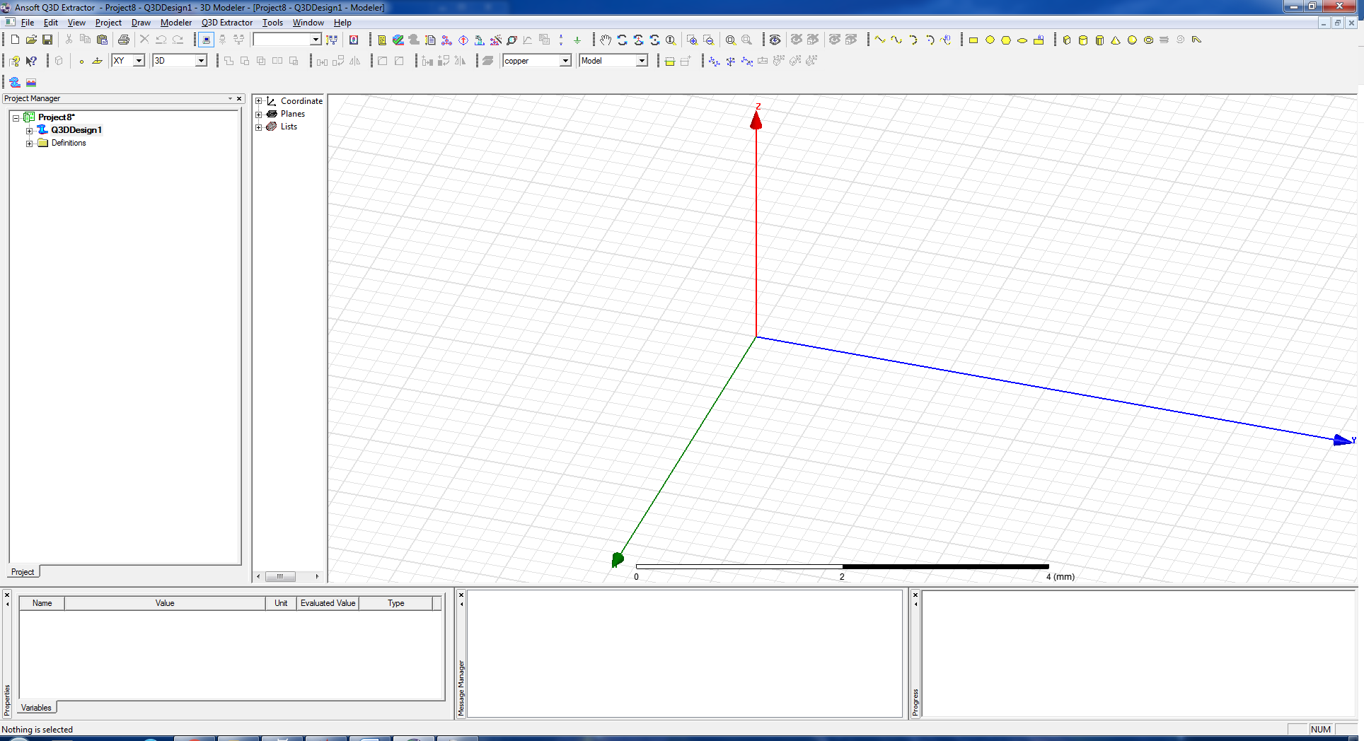

1. To import your design click “Modeler” (at the top) and choose “Import”. Select your design file. The “DXF/DWG Import” window will open. Un-check the box next to “PYDXF”. Click the “Options” tab, and set the “Override” units to micrometers (um). Check the box next to “Import as 2D sheet bodies”. Hit “OK”.

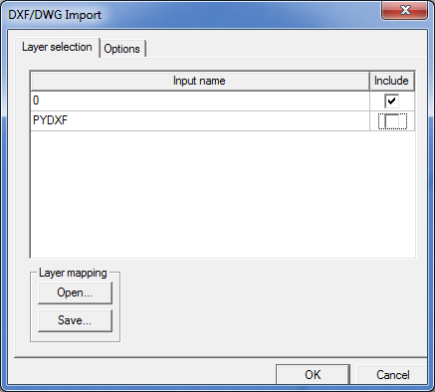 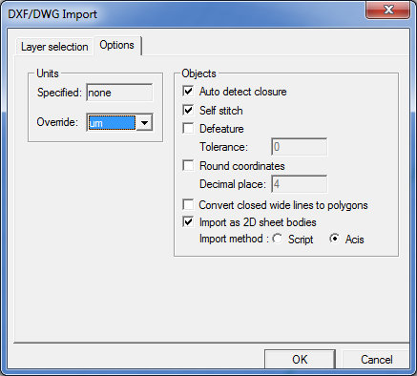

1. Delete the objects from your design that you do not want to include in the capacitance simulation by highlighting them with your cursor and pressing “Delete” on the keyboard. An example “before” and “after” are shown below.

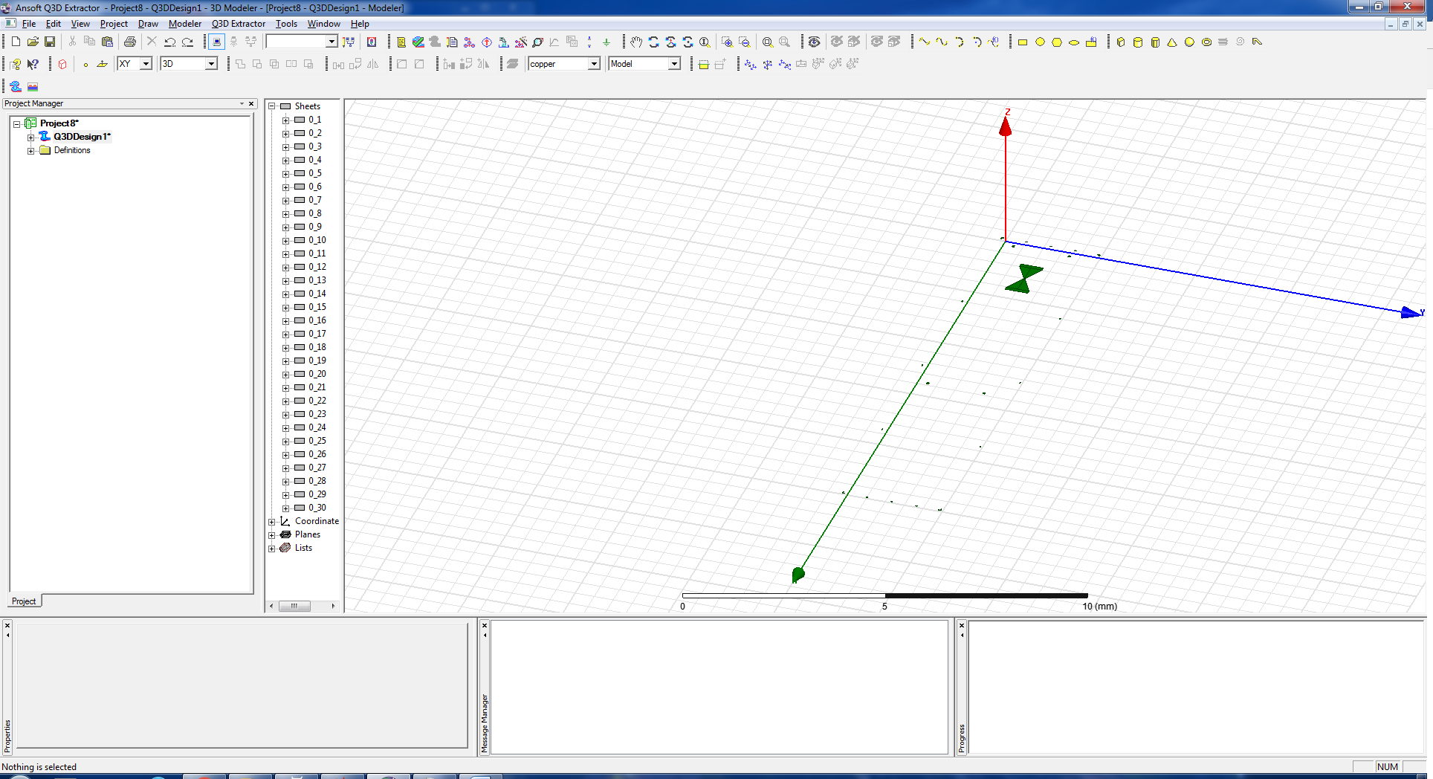

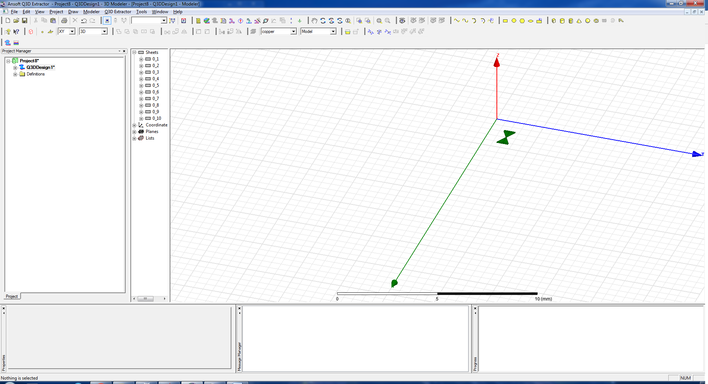

1. Highlight the remaining objects with your cursor. Right click on them and select:

>> “Edit”

>> “Boolean”

>> “Unite”

This will make the objects into continuous shapes.

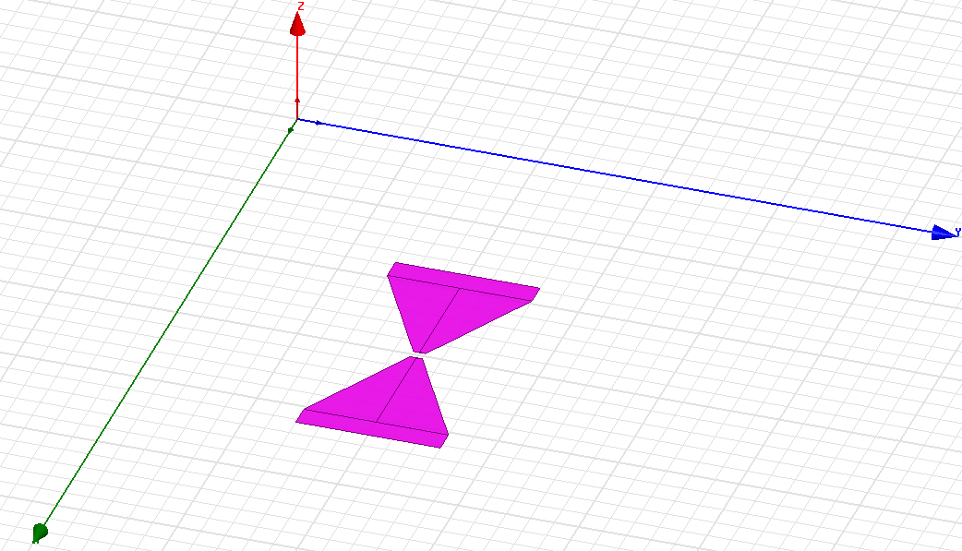 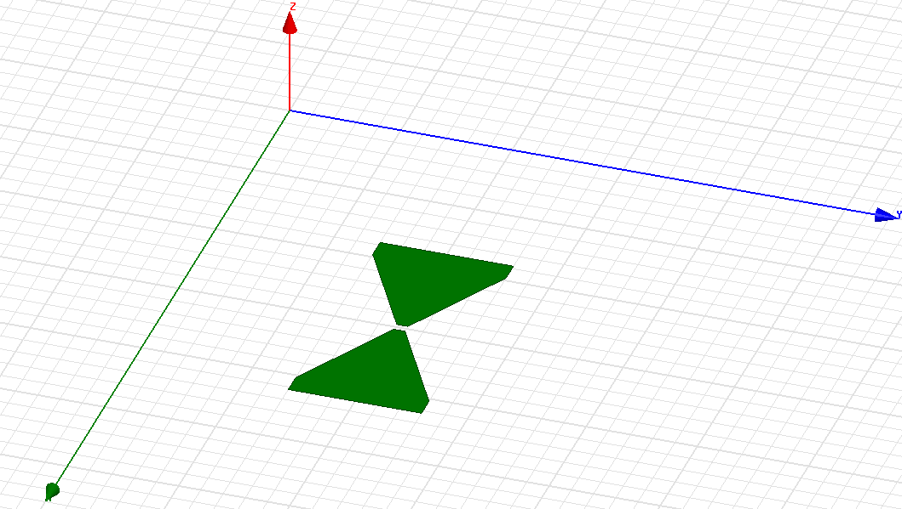

1. Right anywhere and choose “Select Faces”. Highlight the objects again, right click on them, and click:

>> “Edit”

>> “Surface”

>> “Sweep Faces Along Normal”

When the window (shown below) pops up, set the “Length of Sweep” to the thickness of your design, then click “OK”.

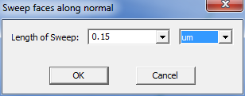

1. In the column to the left, expand the “Solids” and “Not Assigned” tabs.

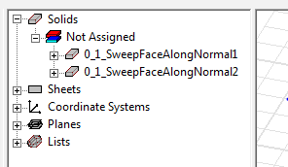

Double-click on each of the solids listed under “Not Assigned”. In the “Properties” window that pops up, click the box next to “Material” and select “Edit”. Scroll down the list of materials until you find “Perfect Conductor” and select it. Hit “Ok” to exit the “Properties” window. Do this for all of the solids you created in the previous step.

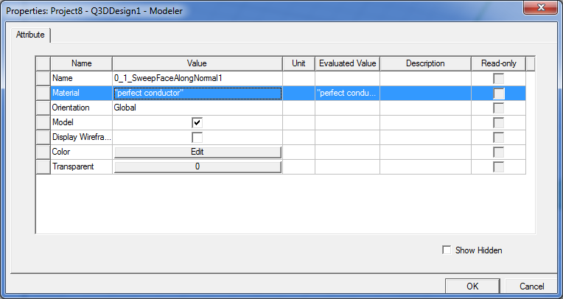

1. To model the substrate that your objects will be on, go to “Draw” in the menu at the top of the screen and click on “Box”. Use the cursor to draw a rectangle around your objects, then drag the cursor down to create the chip under them.

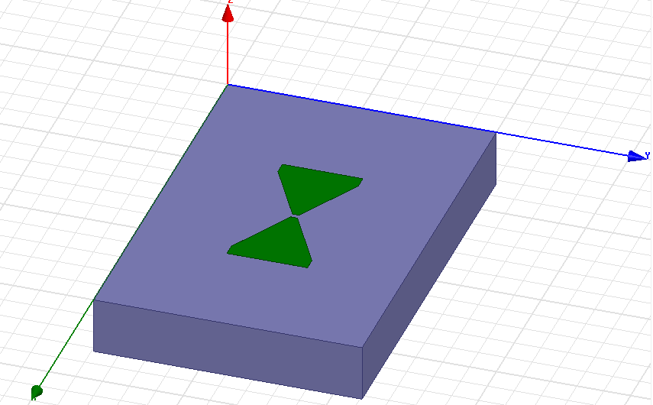

In the column to the left, expand the new solid you just created and double click on “CreateBox”. The “Properties” window (shown below) will pop up. In the box next to “ZSize” enter the thickness of your wafer (negative sign so that it is under your objects), and, if applicable, the units.

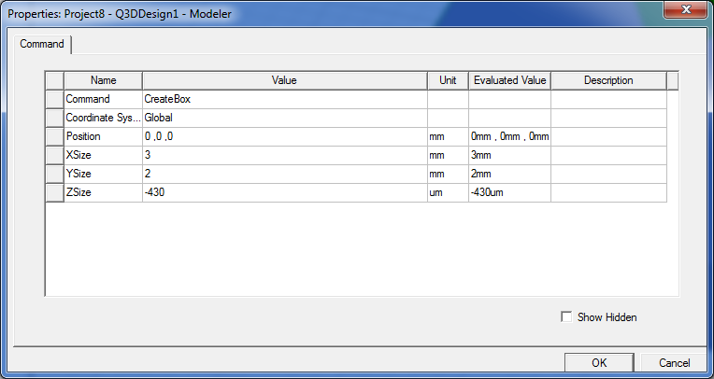

Double-click on the box you just created, and adjust the material, like before. This time choose the appropriate material for your wafer (silicon, sapphire, etc.).

1. To add a column of vacuum above and below your wafer, draw boxes above and below the chip you just created.

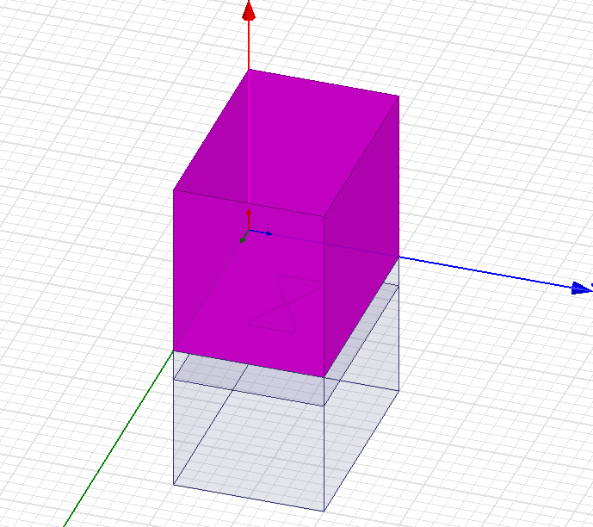

Like before, change the height of these boxes by double-clicking “CreateBox” under their headings in the column to the left. Set the height to be the size of the vacuum on either side of the chip when it’s in the cavity. Change the material of these two new boxes from “copper” to “vacuum”, also.

Optional: In order to the objects you want to measure the capacitance of visible again, you can highlight the top vacuum box by clicking on it in the “Solids” tree. Right click on the highlighted object; then select:

>> “View”

>> “Hide Selection”

1. In the far left column, under your project, expand “Q3DDesign”. Right-click on “Nets” and select “Auto Identify Nets”. Now you will be able to expand under “Nets”. Click on each of the nets listed to make sure they cover all of the objects in your design.

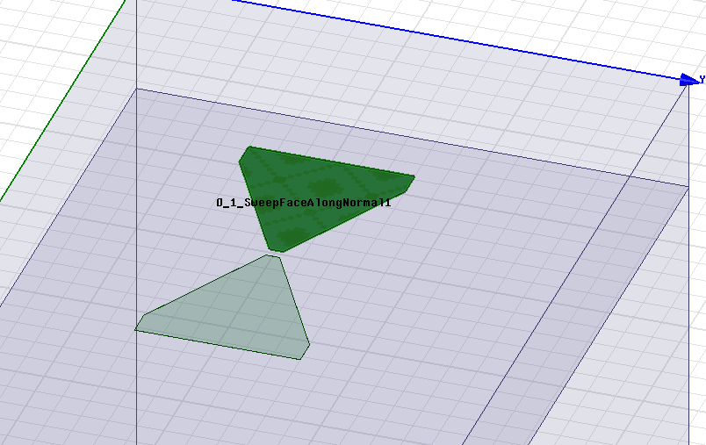

1. Right-click on “Analysis” (again in the far-left column), and choose “Add Solution Setup…”. This will cause the “Solve Setup” window to pop up. Set the “Solution Frequency” to 10GHz. Un-check the boxes next to “DC” and “AC”. Then click on the “CG” tab and set the “Maximum Number of Passes” to a high number, and change the “Maximum Number Converged Passes” to more than 1. Click “OK” to exit the window. Expand under “Analysis”, to show “Setup1”.

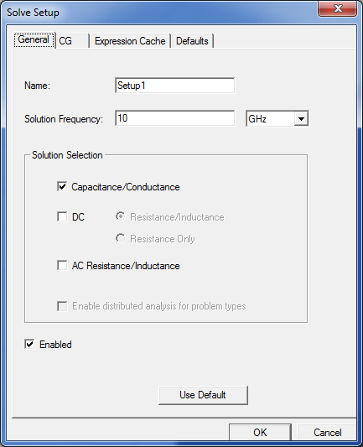 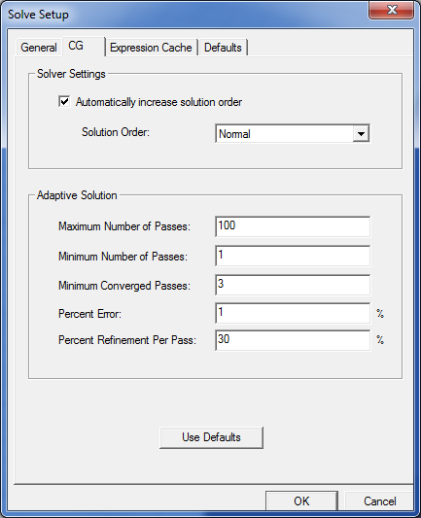

1. Highlight all of the boxes and objects again, and right-click on “Setup1”. Select “Analyze”. A window will pop up asking you to save your project. After doing this, the simulation will run. This may take a while, so DON’T PANIC. If the simulation was successful, you will get a notification at the bottom of the screen:

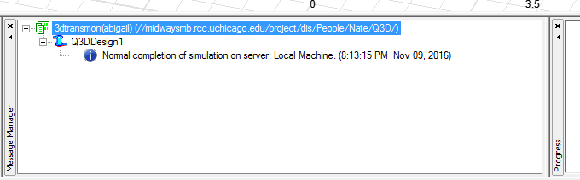

1. To view the solution, go to the far-left column again, and right-click on “Results” under “Analysis”. Select “Solution Data…” from the menu. This will bring up the solutions window (shown below).

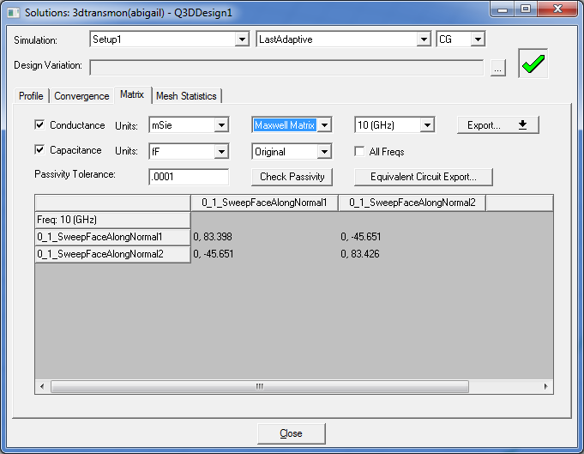

Change the Capacitance units to “fF”. The off-diagonal terms in the matrix (circled in red) represent the capacitance between the objects.

Guide to simulating frequency using ANSYS HFSS

1. Open ANSYS Electronics desktop.
2. Insert HFSS design.
3. Change the solution type: HFSS > Solution Type > Eigenmode
4. Change units: Modeler > Units > [nm or um]. Sometimes if a design has features orders of magnitude smaller than the units, the simulation will fail. This can be solved by changing the units.
5. Import design. This can be done following steps 3-5 in the previous section. If you were drawing the area around your features, you may need to subtract the design from a sheet (insert a rectangle around your design), in order to simulate the design.
6. Identify your design as a conductor: Select your design in the menu. Right click > Add boundary > PerfE > Enter
7. Draw the wafer under your design. Change the height to the height of your wafer, and select the appropriate material.
8. Draw a vacuum box around your stack-up. Change the height to 2120um, and the z position to -860um.
9. Assign a boundary to the vacuum box to account for the boundary of the cap & lid when mounting the sample in the fridge. Select the box in the menu > Right click > Add boundary > PerfE > Enter
10. Add solution setup: Right click on “Analysis” in the project manager > “Add solution setup…”
    1. Set minimum frequency to something below what you expect (Ex. 1GHz)
    2. Set number of modes (I typically set this to one more than the number of resonators on the chip – this makes it easy to confirm that we are looking at the resonator mode and not the box mode)
    3. Maximum number of passes: 99 (or something stupidly high so that it doesn’t time-out)
    4. Maximum Delta frequency per pass: 1
    5. Number of converged passes (under “Options” tab): 3
11. Right click on Setup 1 > “Analyze”
12. After the simulation has converged, Right click on “Results” in the project manager window. Choose “Solution Data”.
13. To plot the first mode:
    1. Select the vacuum box (so that it is highlighted)
    2. Right click on “Field Overlays” in the project manager > Plot Fleids > Mag_E
    3. Choose “In Volume” > AllObjects > Done

This will plot the fields associated with the first mode. This is useful for identifying which mode belongs to the resonator and which belongs to the CPW or box (if they are close in frequency).

Guide to simulating Qc using ANSYS HFSS

1. Follow steps 1-9 from the previous section. Include the CPW and launchers in your design.
2. Add rectangles between the backs of the launchers and the ground plan (as shown below.)

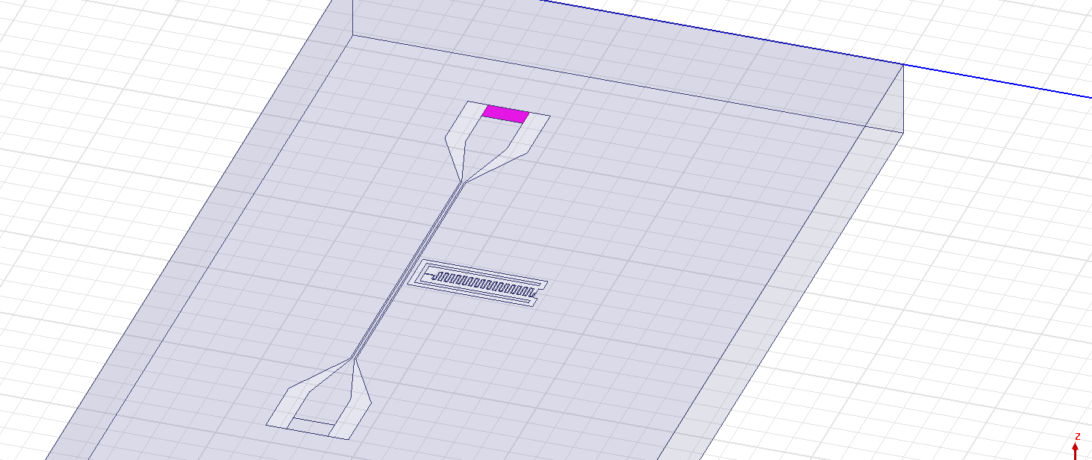

1. For each of these boxes: Right click > Assign boundary > Impedance…
   1. Resistance: 50 Ohm / square
   2. Reactance: 0 Ohm / square
2. Follow steps 10-13 from the previous section.

Guide to simulating the capacitance matrix in ANSYS Maxwell

1. Maxwell 3D > Solution Type > Electrostatic
2. Modeler > Units > um
3. Modeler > Import > [your design]
   1. Un-select PYDXF layer
   2. Units: um
   3. “Import as 2D sheet”
4. Delete unwanted boxes
5. Select remaining shapes > Edit > Boolean > Unite
6. Objects need to be completely separated from ground plane – if needed, add rectangle to shapes to disconnect from ground
7. Draw rectangle around shapes for ground plane
8. Select all > Edit > Boolean > Subtract objects from ground plane
9. Draw substrate and vacuum as described previously
10. Sweep objects across normal (choose thickness of material)
11. Delete the old sheets so that the design is all objects
12. For each object, assign an excitation
    1. Right click > Assign Excitation > Voltage
    2. Set one of these (any one) to -1V, all others can be 0V. This just ensures that it will solve for the capacitances because there is some voltage in the simulation.
13. Parameters > Assign Matrix > Select All
14. Analysis > Add Solution Setup:
    1. Max # passes: 100
    2. Min # converged passes: 3
15. Analyze
16. Solution Data > Matrix
    1. Row, Col correspond to capacitance between those two objects